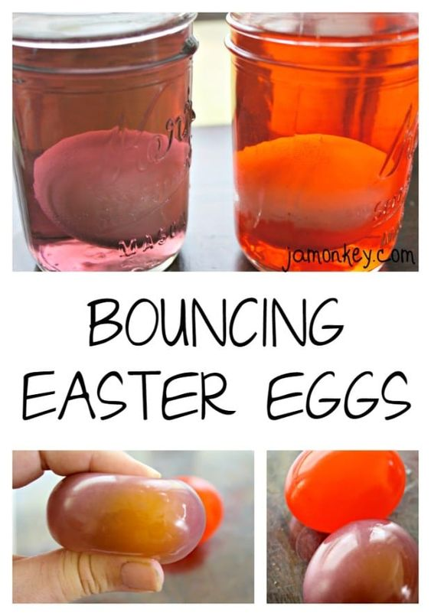

https://pin.it/2aPiHgf

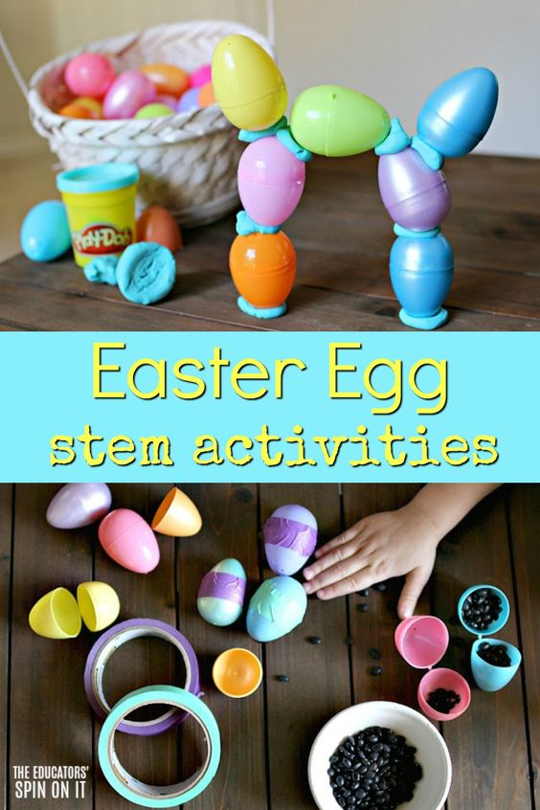

https://pin.it/4ebbq2j

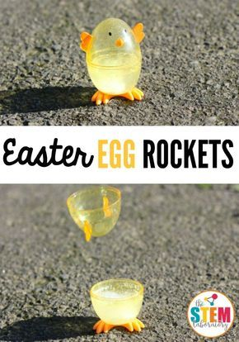

https://pin.it/7k6MH1o

