https://pin.it/72fO9gI

https://pin.it/412fL2d

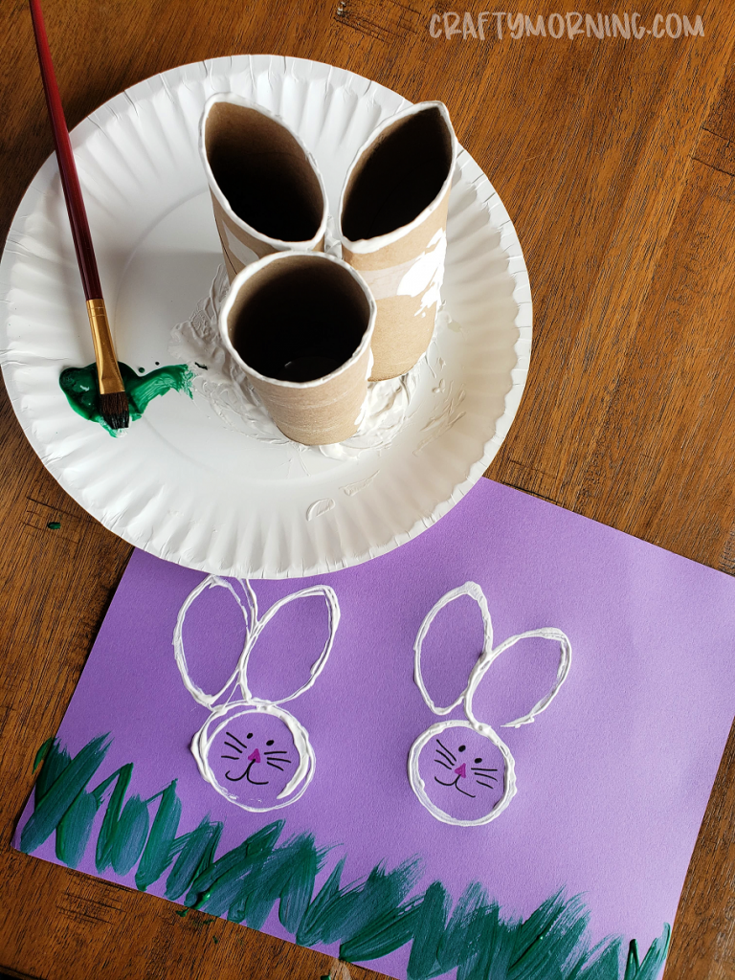

https://pin.it/4Uml96V

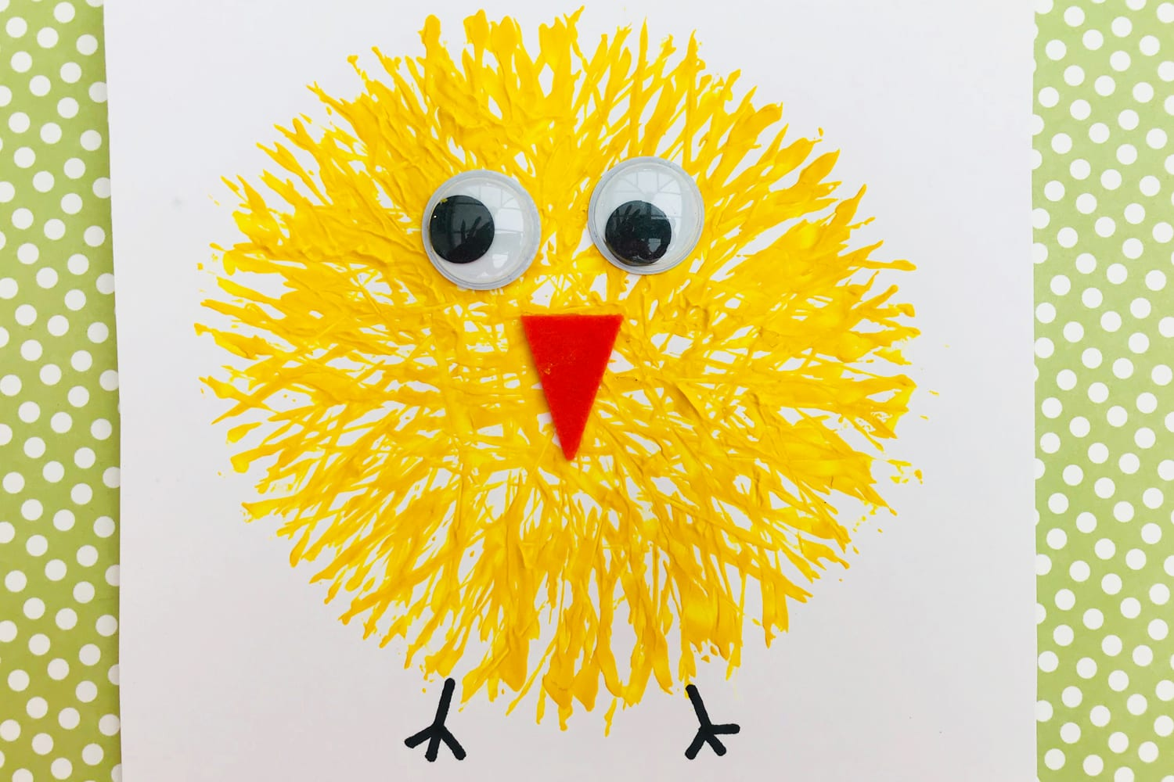

https://pin.it/6XFmDCW

